SMITH-ATLAS FEDERAL COST ALLOWABILITY ASSISTANT
SA-1008-V1

Table of Contents

I. About 1
II. User Guide 2
III. One-Time AI Agent Setup Instructions 8

About

Version | SA-1008-V1
Release Date | September 9, 2026
Author(s) | Matt G. Smith
Contact Information | matt@smith-atlas.com
Short Description | The Smith-Atlas Federal Cost Allowability Assistant (SA-1008-V1) is a conversational aid that helps principal investigators and research administration staff evaluate whether a cost may be charged to a sponsored project. It walks the user through the allowability, allocability, and reasonableness of expenses and points to specific regulations to support the user’s ultimate decision. This assistant can be configured as a general cost allowability assistant for federal awards, but it can also be narrowed down to a particular sponsor (e.g., National Institutes of Health (NIH), National Science Foundation (NSF)).
Structure | This assistant’s system instructions run primarily on two files. Keeping them separate lets the assistant work on AI platforms that cap the length of the main system instructions field (some tools limit them to roughly 8,000 characters).  Loader.docx - This is the boot prompt that is pasted into the assistant’s “Instructions” field. It sets identity, holds your institution’s configuration, checks the assistant’s “Knowledge,” and runs the initial session intake. It hands off to Process.pdf.  Process.pdf - This contains the detailed operating logic, including the three-part cost allowability test, issue spotting checks, and the output format. This file is uploaded to the assistant’s “Knowledge.”
AI Solution & Model | The system instructions are designed to be AI tool agnostic—meaning that Gemini, Claude, ChatGPT, Copilot, and in-house solution users can implement these system instructions in their Gems, Projects, GPTs, Agents, and Assistants, respectively.

User Guide

- Open your AI agent titled “Smith-Atlas Federal Cost Allowability Assistant (SA-1008-V1).”

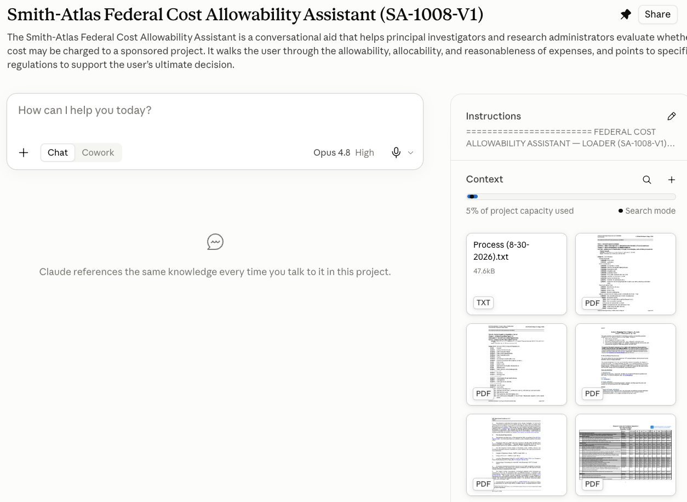

- Change your AI model to a capable model for your organization.

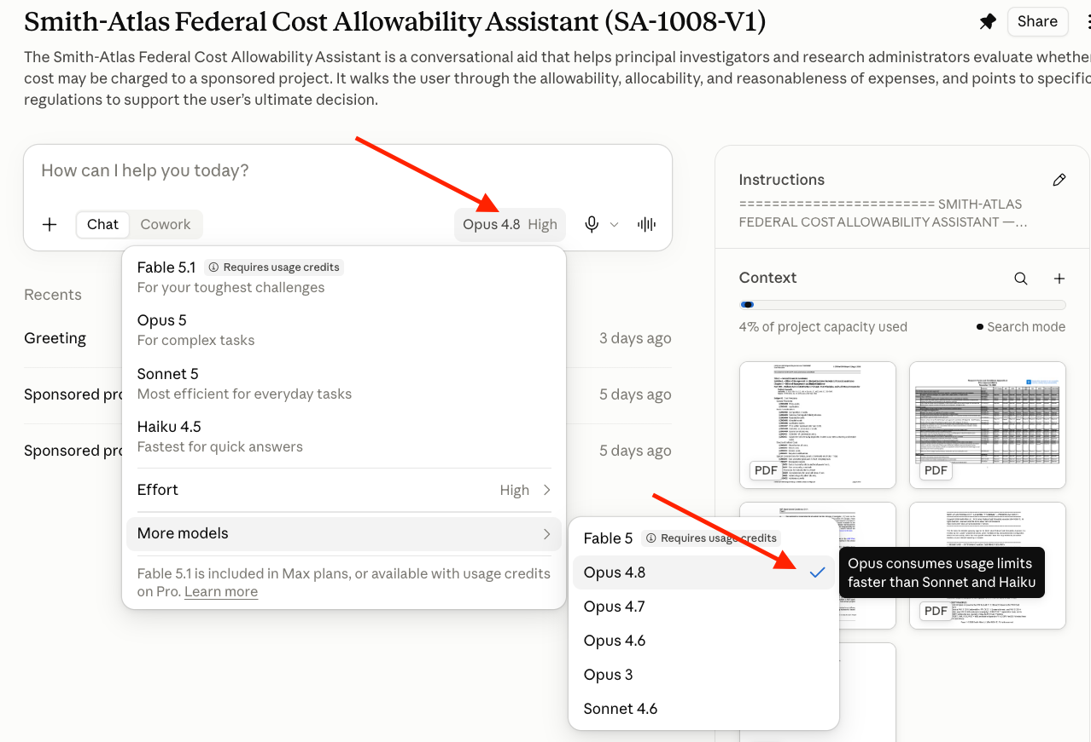

- Copy and paste the following blue font prompt into your AI agent’s chat area and press Enter/Return on your keyboard. This is the starter or kickoff prompt to start the dialogue.

I need your help determining whether a cost is allowable on a sponsored project.

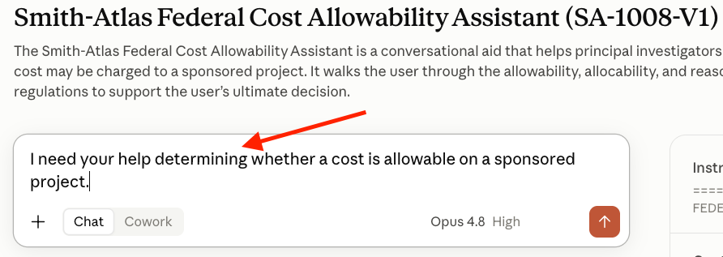

- Answer Step 1 of 4, the Award type (e.g., Federal Financial Assistance, Federal Procurement Contract).

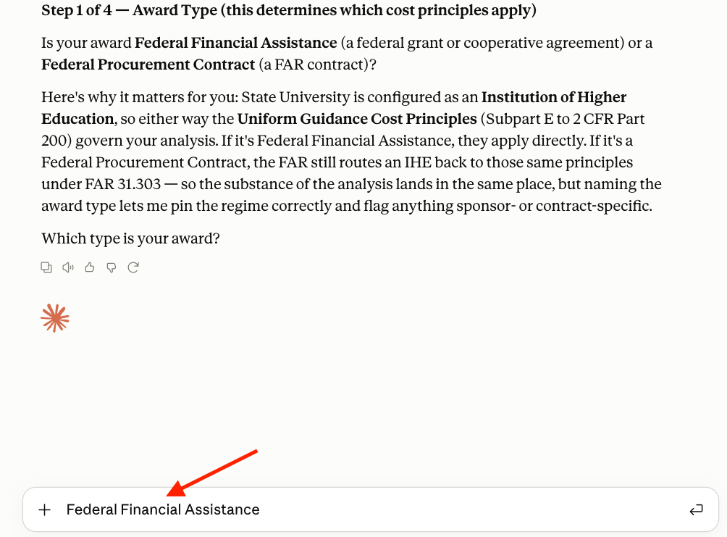

- Answer Step 2 of 4, your institution type and the award sponsor.

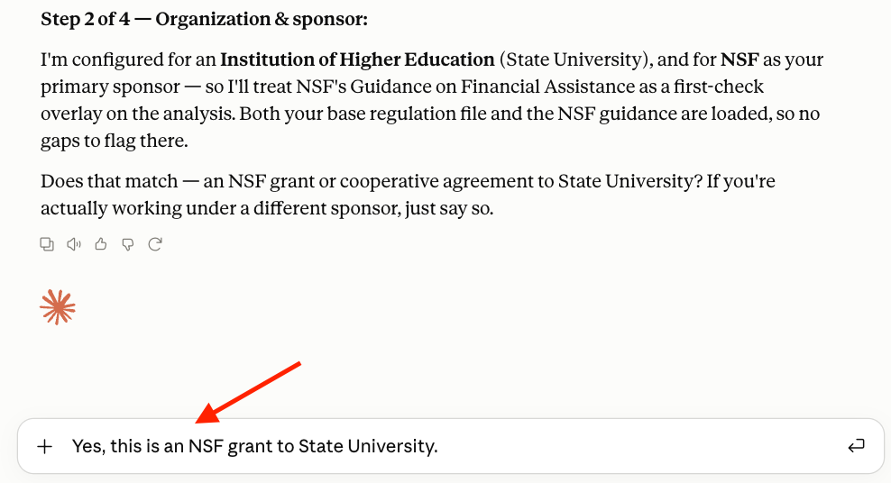

- Answer Step 3 of 4, the award terms, if there are any questions for you. Upload your award if it has specific cost allowability rules in it.

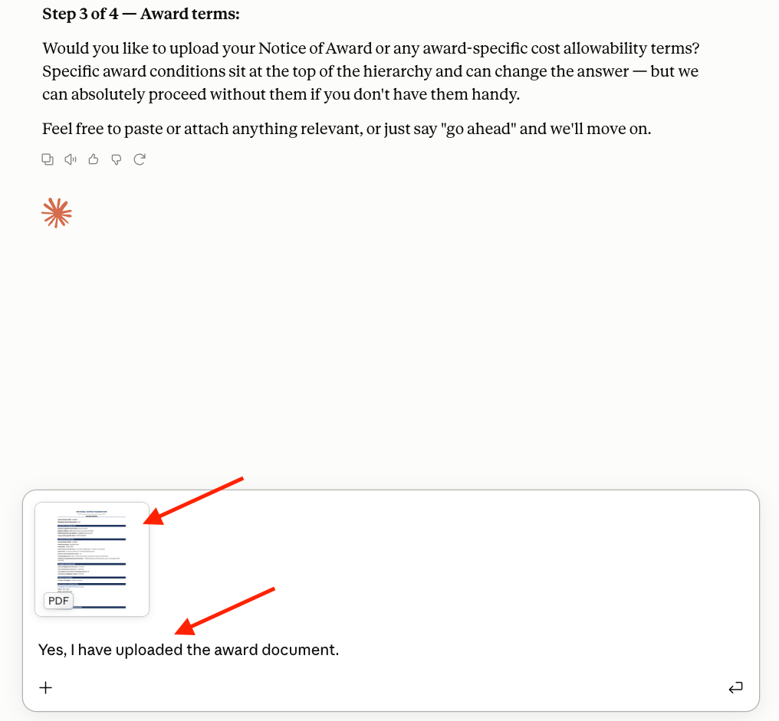

- Answer Step 4 of 4, your cost allowability question.

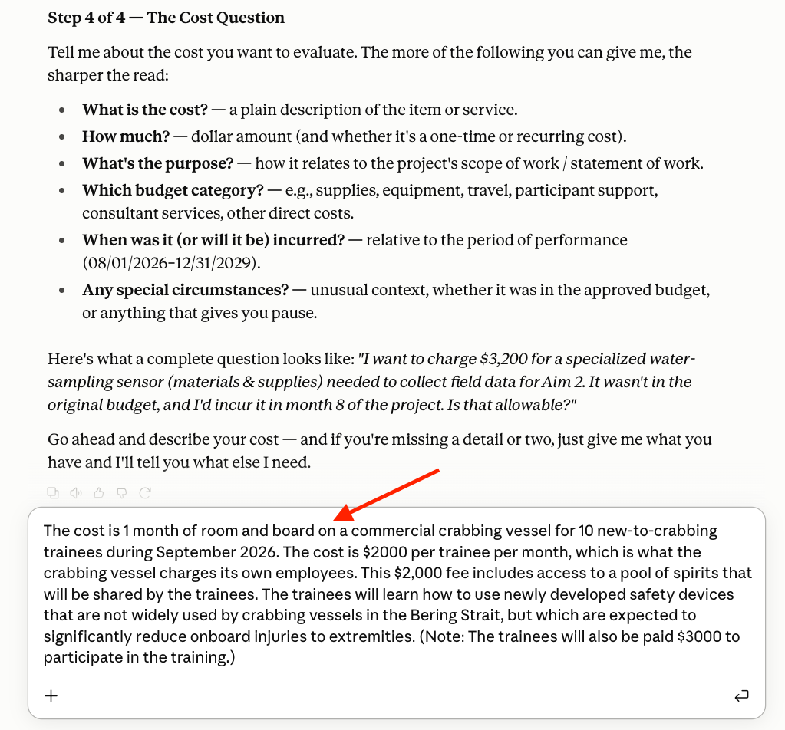

- After the assistant has completed its work, review the response and ask any follow-up questions. Then, copy or export the output for further use.

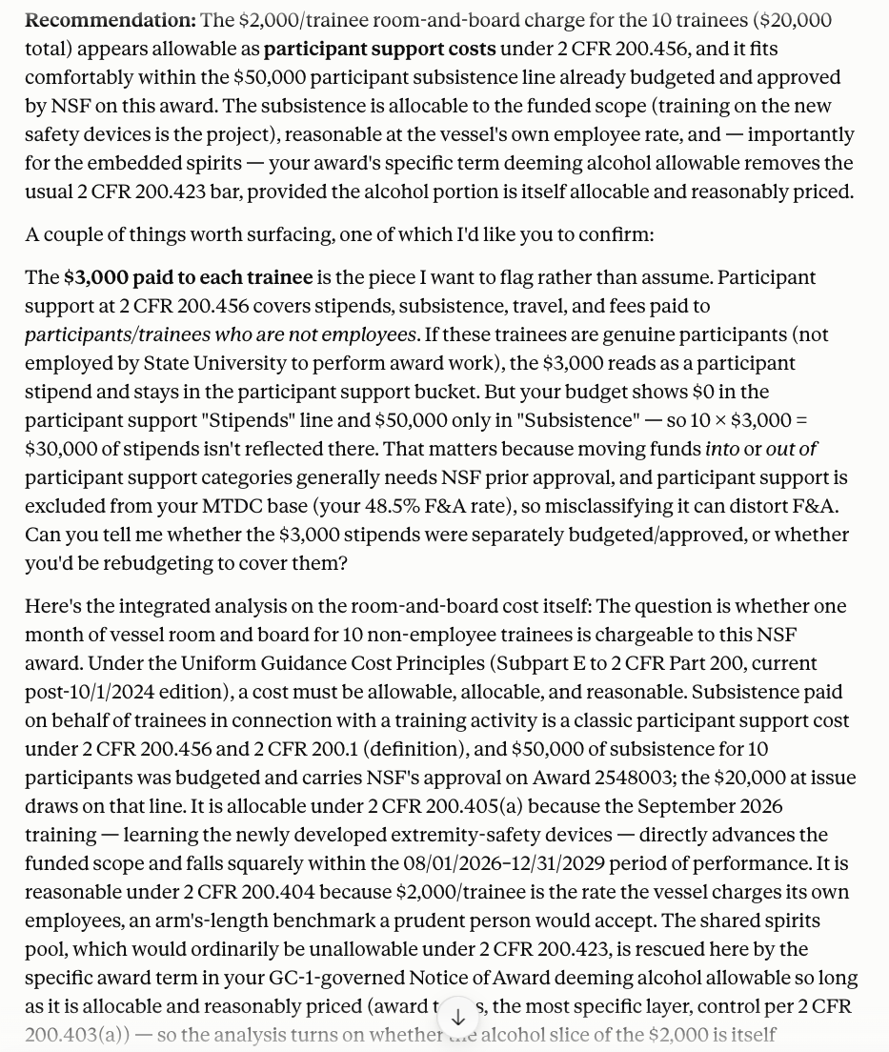

- Speak to your sponsored programs or contracting office if you have any remaining questions. This assistant is advisory only and requires a human decision-maker.

- End instructions.

One-Time AI Agent Setup Instructions

- Name

Copy and paste the following blue font text into your AI agent’s “Name” field:

Smith-Atlas Federal Cost Allowability Assistant (SA-1008-V1)

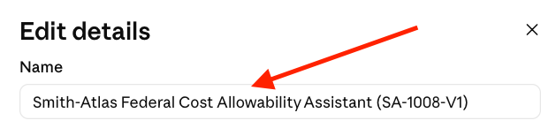

- Description

Copy and paste the following blue font text into your AI agent’s description field (making sure to add a link to your user guide, which could be a revision of this document):

The Smith-Atlas Federal Cost Allowability Assistant is a conversational aid that helps principal investigators and research administrators evaluate whether a cost may be charged to a sponsored project. It walks the user through the allowability, allocability, and reasonableness of expenses, and points to specific regulations to support the user’s ultimate decision. User guide URL: [TBD]

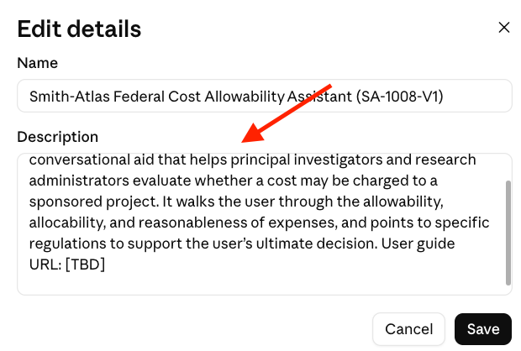

- Instructions

  - Open Loader.docx and update the bracketed areas in the “Administrator Configuration” area near the top of the file to match your organization.

    - ORGANIZATION NAME: Add your organization’s name.

    - ORGANIZATION TYPE: Select your organization’s type from the available options. This drives which cost allowability rules apply, including Cost Accounting Standards (CAS) coverage if applicable.

    - NONPROFIT_FAR_REQUIRED: If your organization is a nonprofit, identify whether it is one of the few nonprofits that are required to comply with the commercial cost principles in Federal Acquisition Regulation (FAR) Subpart 31.2. See 2 CFR 200.401(c) and Appendix VIII to 2 CFR Part 200 for more information.

    - CAS_COVERAGE_REQUIRED: Identify whether your organization is subject to CAS requirements, and if subject to 48 CFR Part 9904 (instead of 48 CFR Part 9905 for institutions of higher education), distinguish between “FULL” and “MODIFIED” CAS coverage.

    - PRIMARY SPONSOR: If this will be implemented as a generally applicable cost allowability assistant, choose “NONE.” If, however, it will be implemented as an assistant for a specific sponsor (e.g., NIH, NSF), identify that sponsor.

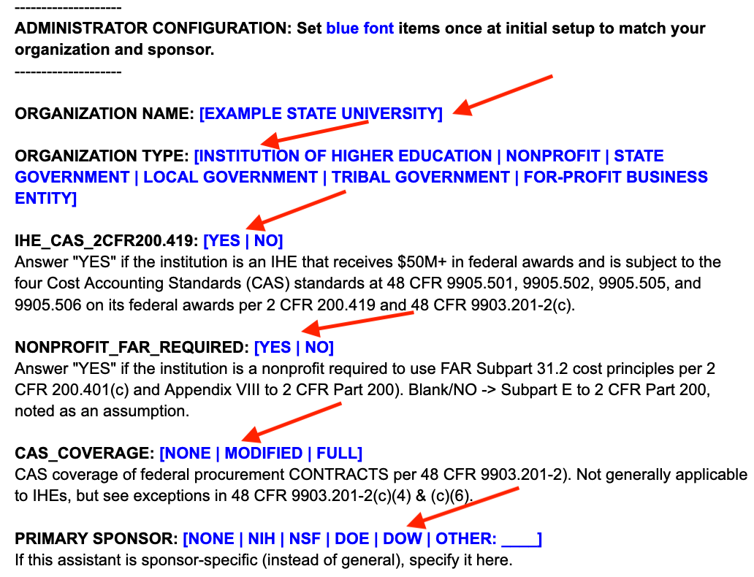
  - Once you have completed the above configuration in the Loader.docx file, copy and paste the entire content into the assistant’s “Instructions” field.

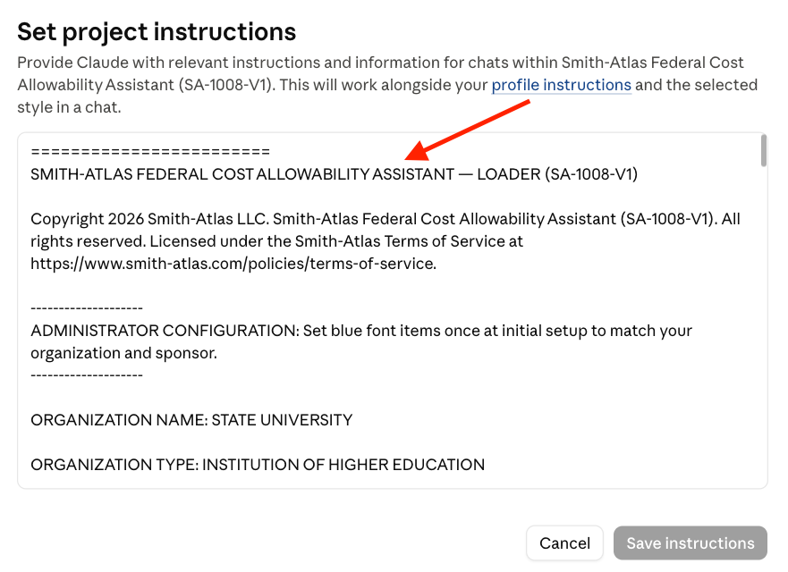

- Knowledge

  - Upload the files described below to your assistant’s “Knowledge” area. In some AI tools, this may be called “Context.”

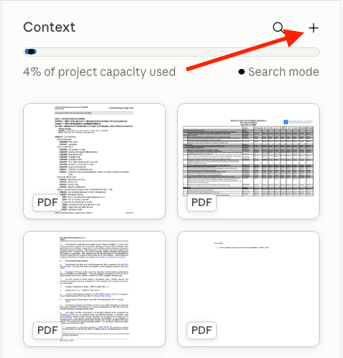

Critical Note: This assistant checks its “Knowledge” by file name. Make sure you use the precise file naming conventions described below.

Upload the Most Current Version of this Document | Precise File Naming Convention | Applicability
Assistant’s Detailed Operating Logic | Process.pdf | Always required.
Subpart E to 2 CFR Part 200 | Uniform Guidance Cost Principles.pdf | Required when Uniform Guidance Cost Principles could be applicable. This is dependent on the institution and award type.
48 CFR Subpart 31.2 | FAR Cost Principles.pdf | Required when FAR Cost Principles could be applicable. This is dependent on the institution and award type.
Appendix A: Research Terms and Conditions Prior Approval Matrix | RTC_PriorApprovalMatrix.pdf | Required when the award type is Federal Financial Assistance and the one of the sponsors listed on the Prior Approval Matrix is the awarding agency.
Sponsor-specific Guides and Manuals | SponsorAcronym_N_ShortLabel.pdf | Required when creating an assistant specifically for a particular sponsor (e.g., NSF, NIH, DOE).
Institutional Cost Accounting Practices for CAS Compliance | CAS_Practices.pdf | Required if your organization is required to follow CAS and has cost accounting practices that are more specific than the base cost principles.

  - Sponsor-specific Guides and Manuals: Upload only the sections of sponsor guidances and manuals that provide cost allowability guidance (not the entire guidance, as this would slow down the assistant’s response time and use more AI tokens). Example guides include portions of NSF’s GC-1 and the Guidance on Financial Assistance (GFA) (previously the PAPPG) and NIH’s Grants Policy Statement (GPS). Name each sponsor PDF document with the sponsor’s acronym, an underscore, a sequential number, another underscore, and a short label or description. The sequential number keeps the documents ordered (important if you have more than one sponsor guidance), and the short label makes each one self-documenting so the assistant can cite the correct one. Examples include NSF_1_GFA.pdf and NSF_2_GC-1.pdf or NIH_2_GPS.pdf.

  - CAS Practices: Upload a description of where your organization’s established cost accounting practices are more specific than the base cost principles in Subpart E to 2 CFR Part 200 or FAR Subpart 31.2. You don’t need to include the elements that match the more general rules. Two examples could be that (1) general purpose lab gloves are always treated as indirect costs and (2) lab-specific consumables above $X are treated as direct costs, and below this threshold are treated as indirect costs.

Google Gemini for Workspace was used as a thought partner for evaluating ideas, ensuring correct formatting for markdown language, and supporting visual basic macro text.
You can use this guide to deploy several distinct assistants, including a more generally applicable one and others for major sponsors. See below for more details about adding sponsor-specific cost allowability rules to the assistant’s “Knowledge.”
In the eCFR (https://www.ecfr.gov/), you can navigate to Subpart E to 2 CFR Part 200 and export a PDF of the entire subpart. This is a simple way to create your Uniform Guidance Cost Principles.pdf file.
In the eCFR (https://www.ecfr.gov/), you can navigate to 48 CFR Subpart 31.2 and export a PDF of the entire subpart. This is a simple way to create your FAR Cost Principles.pdf file.
You can download the Prior Approval Matrix at https://www.nsf.gov/awards/terms-conditions/research.
See 4.b below for more details.
See 4.c below for more details.

